Business questions:

1. Describe the correlation of vehicles price on other factors. Find most significant.

2. Find the most selling region to go to

3. Find underestimated vehicles TO make the profitable deal

1. Calculating correlation koefficient for the manufacturers prices with year and odometer:

-- create view for the average data

**CREATE** **OR** **REPLACE** **VIEW** avg_data **AS** -- I need average DATA FOR the correlations

**SELECT**

vt.manufacturer,

**round**(**avg**(p.price), 2) **AS** avg_price,

**round**(**avg**(p.odometer)) **AS** avg_odometer,

**avg**(p."year") **AS** avg_year

**FROM** uv.publications p

**JOIN** uv.vehicle_titles vt **USING** (vt_id)

**GROUP** **BY** vt.manufacturer;

**SELECT** * **FROM** avg_data;

Result:

|  |  |  |  |
| --- | --- | --- | --- |
| manufacturer | avg_price | avg_odometer | avg_year |
| acura | 24752.45 | 56454 | 2015.3935965334617236 |
| alfa-romeo | 29978.82 | 33723 | 2017.7956298200514139 |
| aston-martin | 56230.46 | 19826 | 2013.0000000000000000 |
| audi | 28182.45 | 55256 | 2015.4858646909728992 |
| bmw | 24122.87 | 64589 | 2014.0409157882806302 |
| buick | 19460.77 | 67093 | 2014.3441138421733506 |
| cadillac | 25987.35 | 62238 | 2014.4484038604305865 |
| chevrolet | 24198.97 | 83766 | 2012.9081182896967414 |
| chrysler | 13702.00 | 87342 | 2012.6294579172610556 |
| datsun | 19784.54 | 73105 | 1976.6153846153846154 |
| dodge | 20390.36 | 74389 | 2013.9649235720032180 |
| ferrari | 140656.76 | 22224 | 2007.0204081632653061 |
| fiat | 14406.56 | 45160 | 2015.5708737864077670 |
| ford | 25579.64 | 89741 | 2013.2431164479195755 |
| gmc | 29850.24 | 84281 | 2013.9012213413327619 |
| harley-davidson | 13460.58 | 40664 | 2008.7741935483870968 |
| honda | 14153.70 | 97585 | 2012.3609941872118661 |
| hyundai | 14133.30 | 73212 | 2014.7870695713281799 |
| infiniti | 24444.64 | 58995 | 2015.2444987775061125 |
| jaguar | 30978.75 | 34159 | 2015.8751773049645390 |
| jeep | 24062.84 | 71631 | 2014.0206925236560258 |
| kia | 14886.15 | 66390 | 2015.5336170212765957 |
| land rover | 5716.33 | 111601 | 2001.0000000000000000 |
| lexus | 23257.00 | 76014 | 2012.9739542225730071 |
| lincoln | 25015.90 | 55220 | 2014.9730856709628506 |
| mazda | 16839.54 | 71659 | 2013.9366621983914209 |
| mercedes-benz | 25912.97 | 67847 | 2012.8737298017657838 |
| mercury | 5917.09 | 131176 | 2003.3459459459459459 |
| mini | 18174.48 | 55195 | 2014.4588804422944022 |
| mitsubishi | 17883.35 | 54675 | 2015.4444444444444444 |
| nissan | 16347.46 | 79673 | 2014.2764325627259779 |
| pontiac | 9283.93 | 116654 | 2003.0610465116279070 |
| porsche | 37586.41 | 70905 | 2010.4444444444444444 |
| ram | 34187.70 | 79961 | 2015.3437925004857198 |
| rover | 30748.19 | 60022 | 2014.7984693877551020 |
| saturn | 7003.53 | 104821 | 2006.7394736842105263 |
| subaru | 16631.44 | 83390 | 2013.8386167146974063 |
| tesla | 39015.91 | 35197 | 2016.7363112391930836 |
| toyota | 20959.06 | 90076 | 2012.8408437200383509 |
| volkswagen | 16613.98 | 62219 | 2014.2731021555763824 |
| volvo | 24024.76 | 65072 | 2014.6418491484184915 |

-- 1.1 price with odometer (numerical - numerical) --- Pearson coefficient RESULT --- 0.4131681089025605

**SELECT** **sum**((p.price - avg_data.avg_price) * (p.odometer - avg_data.avg_odometer))/ |/(**sum**((p.price - avg_data.avg_price)^2)* **sum**((p.odometer - avg_data.avg_odometer)^2)) **AS** price_odometer

**FROM** uv.publications p

**JOIN** uv.vehicle_titles vt **USING**(vt_id)

**JOIN** avg_data **ON** avg_data.manufacturer = vt.manufacturer;

-- 1.2. price with YEAR (numerical - numerical) --- Pearson coefficient RESULT 0.4752106053941027

**SELECT** **sum**((p.price - avg_data.avg_price) * (p."year" - avg_data.avg_year))/ |/(**sum**((p.price - avg_data.avg_price)^2)* **sum**((p."year"- avg_data.avg_year)^2)) **AS** price_year

**FROM** uv.publications p

**JOIN** uv.vehicle_titles vt **USING**(vt_id)

**JOIN** avg_data **ON** avg_data.manufacturer = vt.manufacturer;

-- 1.3. price with year for models of the cars - Spearman coefficient

**SELECT** manufacturer,

1 - (6\***sum**(rank_diff^2) / (**count**(manufacturer)*(**count**(manufacturer)^2-1))) **AS** correlation_spierman

**FROM**

(**SELECT** vt.manufacturer,

p.price,

p."year",

**RANK**() **OVER** (**PARTITION** **BY** vt.manufacturer **ORDER** **BY** p.price) **AS** price_rank, -- ranking models by prices

**DENSE_RANK** () **OVER** (**PARTITION** **BY** vt.manufacturer **ORDER** **BY** p."year" **DESC**) **AS** year_rank,-- ranking models BY YEAR

**RANK**() **OVER** (**PARTITION** **BY** vt.manufacturer **ORDER** **BY** p.price) - **DENSE_RANK** () **OVER** (**PARTITION** **BY** vt.manufacturer **ORDER** **BY** p."year" **desc**) **AS** rank_diff

**FROM** uv.publications p

**JOIN** uv.vehicle_titles vt **using**(vt_id)

**GROUP** **BY** vt.manufacturer, p.price, p."year") tab

**GROUP** **BY** manufacturer

**ORDER** **BY** correlation_spierman;

RESULT:

|  |  |
| --- | --- |
| manufacturer | correlation_spearman |
| jaguar | -0,962 |
| lincoln | -0,948 |
| infiniti | -0,939 |
| acura | -0,910 |
| buick | -0,901 |
| subaru | -0,900 |
| mini | -0,884 |
| honda | -0,882 |
| kia | -0,874 |
| mazda | -0,872 |
| volvo | -0,863 |
| hyundai | -0,863 |
| lexus | -0,858 |
| audi | -0,843 |
| cadillac | -0,841 |
| chrysler | -0,830 |
| mercedes-benz | -0,822 |
| bmw | -0,818 |
| mitsubishi | -0,806 |
| volkswagen | -0,793 |
| nissan | -0,785 |
| dodge | -0,781 |
| rover | -0,772 |
| gmc | -0,760 |
| toyota | -0,738 |
| jeep | -0,733 |
| ferrari | -0,703 |
| alfa-romeo | -0,701 |
| ram | -0,690 |
| ford | -0,669 |
| saturn | -0,619 |
| fiat | -0,607 |
| porsche | -0,595 |
| chevrolet | -0,572 |
| aston-martin | -0,492 |
| tesla | -0,419 |
| harley-davidson | -0,260 |
| mercury | -0,220 |
| datsun | -0,145 |
| pontiac | 0,141 |
| land rover | 0,500 |

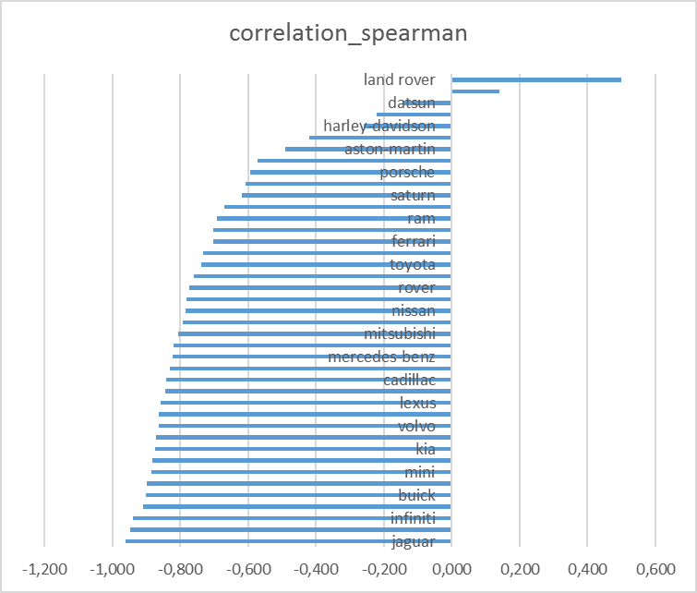

-- 2. dependence of number selling cars on region. Find the most selling region - where to go

**SELECT**

state,

region,

quantity_of_sales

**FROM**

(**SELECT** l.state,

l.region,

**count**(p.price) **AS** quantity_of_sales,

**RANK** () **OVER** (**PARTITION** **BY** l.state **ORDER** **BY** **count**(p.price) **DESC**) **AS** state_rank

**FROM** uv.publications p

**JOIN** uv.locations l **ON** p.loc_id = l.loc_id

**GROUP** **BY** l.region, l.state) tab

**WHERE** state_rank <= 3;

RESULT:

|  |  |  |
| --- | --- | --- |
| state | region | quantity_of_sales |
| fl | sarasota-bradenton | 2158 |
| ak | anchorage / mat-su | 2149 |
| or | portland | 1840 |
| ca | stockton | 1832 |
| az | tucson | 1792 |
| nj | central NJ | 1781 |
| ia | des moines | 1772 |
| id | boise | 1740 |
| tn | nashville | 1740 |
| mi | grand rapids | 1735 |
| dc | washington, DC | 1713 |
| wa | seattle-tacoma | 1707 |
| pa | pittsburgh | 1621 |
| md | baltimore | 1575 |
| ks | kansas city, MO | 1526 |
| ny | new york city | 1521 |
| ma | boston | 1516 |
| tx | san antonio | 1506 |
| oh | cincinnati | 1465 |
| co | colorado springs | 1453 |
| mn | minneapolis / st paul | 1453 |
| nh | new hampshire | 1450 |
| wi | madison | 1433 |
| ok | oklahoma city | 1378 |
| il | st louis, MO | 1369 |
| nv | las vegas | 1360 |
| ct | hartford | 1321 |
| vt | vermont | 1277 |
| hi | hawaii | 1276 |
| ga | atlanta | 1263 |
| nm | albuquerque | 1249 |
| in | indianapolis | 1246 |
| va | norfolk / hampton roads | 1195 |
| nc | raleigh / durham / CH | 1148 |
| ky | louisville | 1135 |
| mt | billings | 1122 |
| ri | rhode island | 1023 |
| sc | greenville / upstate | 1017 |
| me | maine | 986 |
| ct | new haven | 900 |
| al | birmingham | 839 |
| mo | columbia / jeff city | 633 |
| la | new orleans | 568 |
| de | delaware | 466 |
| ar | fayetteville | 410 |
| wv | charleston | 336 |
| ne | lincoln | 306 |
| sd | sioux falls / SE SD | 306 |
| ut | salt lake city | 287 |
| ms | north mississippi | 165 |
| nd | grand forks | 73 |

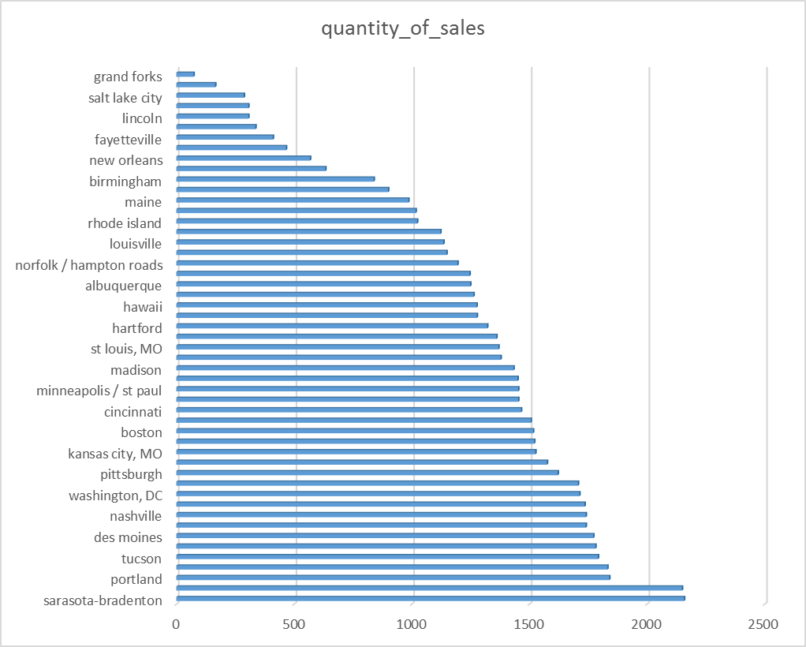

-- 3. underestimated vehicles TO make the profitable deal with the production year above 2000 having gas engine, automatic transmission and 4wd drive

**SELECT** url,

posting_date,

region,

manufacturer,

model,

**to_char**(price, '99 999.00') **AS** "price $",

**to_char**(**round**(avg_price_model, 2), '99 999.00') **AS** "avg_price $",

**to_char**(avg_price_model - price, '99 999.99') **AS** "profit $"

**FROM**

(**SELECT** p.url,

p.posting_date,

l.region,

vt.manufacturer,

vt.model,

p.price,

**avg**(p.price) **OVER** (**PARTITION** **BY** vt.model) **AS** avg_price_model

**FROM** uv.publications p

**JOIN** uv.locations l **USING** (loc_id)

**JOIN** uv.vehicle_titles vt **USING** (vt_id)

**JOIN** uv.v_engines ve **ON** ve.veng_id = p.veng_id

**JOIN** uv.vehicle_body vb **USING** (vb_id)

**JOIN** uv.drives d **ON** d.drive_id = vb.drive_id

**JOIN** uv.transmissions t **ON** t.trm_id = vb.trm_id

**WHERE** p."year" >= 2000

**AND** ve.fuel = 'gas'

**AND** d.drive_type = '4wd'

**AND** t.trm_type = 'automatic'

**GROUP** **BY** vt.manufacturer, vt.model, p.price, p.url, p.posting_date, l.region) tab

**WHERE** avg_price_model - price > 0

**AND** price > 20000 **AND** price < 40000

**ORDER** **BY** avg_price_model - price **DESC**

**LIMIT** 10;

|  |  |  |  |  |  |  |  |  |  |  |  |  |  |  |  |  |  |  |  |  |  |  |  |  |  |  |  |  |  |  |  |  |  |  |  |  |  |  |  |  |  |  |  |  |  |  |  |  |  |  |  |  |  |  |  |  |  |  |  |  |  |  |  |  |  |  |  |  |  |  |  |  |  |  |  |  |  |  |  |  |  |  |  |  |  |  |  |  |  |  |  |  |  |  |  |
| --- | --- | --- | --- | --- | --- | --- | --- | --- | --- | --- | --- | --- | --- | --- | --- | --- | --- | --- | --- | --- | --- | --- | --- | --- | --- | --- | --- | --- | --- | --- | --- | --- | --- | --- | --- | --- | --- | --- | --- | --- | --- | --- | --- | --- | --- | --- | --- | --- | --- | --- | --- | --- | --- | --- | --- | --- | --- | --- | --- | --- | --- | --- | --- | --- | --- | --- | --- | --- | --- | --- | --- | --- | --- | --- | --- | --- | --- | --- | --- | --- | --- | --- | --- | --- | --- | --- | --- | --- | --- | --- | --- | --- | --- | --- | --- |
| |  |  |  |  |  |  |  |  | | --- | --- | --- | --- | --- | --- | --- | --- | | url | posting_date | region | manufacturer | model | price $ | avg_price $ | profit $ | | https://poconos.craigslist.org/ctd/d/east-stroudsburg-2011-porsche-panamera/7317070385.html | 2021-05-04 22:08:23.000 | poconos | porsche | panamera turbo | 37 990.00 | 76 295.00 | 38 305.00 | | https://wichita.craigslist.org/ctd/d/wichita-2007-porsche-911-4s-carrera/7305834749.html | 2021-04-12 15:24:01.000 | wichita | porsche | 911 | 37 990.00 | 64 630.00 | 26 640.00 | | https://knoxville.craigslist.org/ctd/d/lenoir-city-2016-lincoln-navigator/7303335196.html | 2021-04-07 16:54:09.000 | knoxville | lincoln | navigator l | 24 999.00 | 50 698.43 | 25 699.43 | | https://boulder.craigslist.org/ctd/d/longmont-2016-land-rover-range-rover/7314340229.html | 2021-04-29 09:48:54.000 | boulder | rover | sport hs | 37 999.00 | 61 599.67 | 23 600.67 | | https://cnj.craigslist.org/ctd/d/miami-2020-jeep-gladiator-sport-4x4-4dr/7311619722.html | 2021-04-23 18:34:34.000 | central NJ | jeep | gladiator | 27 950.00 | 50 858.17 | 22 908.17 | | https://austin.craigslist.org/ctd/d/miami-2020-jeep-gladiator-sport-4x4-4dr/7311614249.html | 2021-04-23 17:22:55.000 | austin | jeep | gladiator | 27 950.00 | 50 858.17 | 22 908.17 | | https://bend.craigslist.org/ctd/d/portland-2001-toyota-land-cruiser-new/7311698854.html | 2021-04-23 19:03:33.000 | bend | toyota | land cruiser | 21 995.00 | 41 507.15 | 19 512.15 | | https://madison.craigslist.org/ctd/d/madison-2010-ford-150-svt-raptor/7314736669.html | 2021-04-30 07:30:41.000 | madison | ford | f-150 svt raptor | 21 995.00 | 40 700.50 | 18 705.50 | | https://missoula.craigslist.org/ctd/d/missoula-2016-lincoln-navigator-reserve/7312375976.html | 2021-04-25 10:42:34.000 | missoula | lincoln | navigator reserve | 29 995.00 | 48 371.00 | 18 376.00 | | https://sanantonio.craigslist.org/ctd/d/san-antonio-2014-ford-150-limited-4x4/7316211038.html | 2021-05-03 10:19:44.000 | san antonio | ford | f-150 limited 4x4 | 25 600.00 | 43 863.33 | 18 263.33 | |  |  |  |  |  |  |  |

|  |  |  |  |  |  |  |  |
| --- | --- | --- | --- | --- | --- | --- | --- |
|  |  |  |  |  |  |  |  |
|  |  |  |  |  |  |  |  |
|  |  |  |  |  |  |  |  |
|  |  |  |  |  |  |  |  |
|  |  |  |  |  |  |  |  |
|  |  |  |  |  |  |  |  |
|  |  |  |  |  |  |  |  |
|  |  |  |  |  |  |  |  |
|  |  |  |  |  |  |  |  |
|  |  |  |  |  |  |  |  |